HARDWARES AND SOFTWARES REQUIRED

HARDWARES
1. Desktop / Laptop
2. Mobile Phone

SOFTWARES
1. Python (3.14.0)
2. MySQL
3. MySQL Connector Module
4. pip
S.no. | Topic | Page No.
1. | Introduction
2. | Python Source Code
3. | MySQL Database
4. | Outputs
5. | References
CONTENTS

INTRODUCTION

Objective:
To develop an efficient, user-friendly, and scalable hotel management system that meets the needs of hotel staff, guests, and management.

Hotel Management System (HMS)
Project Overview:
The Hotel Management System is a comprehensive software solution designed to streamline hotel operations, enhance guest experience, and improve administrative efficiency. This system aims to automate tasks, manage room bookings, guest information, staff schedules, and provide real-time insights for informed decision-making.

Key Features:

- Room booking and management

- Guest information management

- Staff scheduling and management

- Billing and payment processing

- Reporting and analytics

Advantages over Previous System:

- Improved Efficiency: Automated tasks reduce manual errors and increase productivity.

- Enhanced Guest Experience: Streamlined booking and check-in processes ensure a seamless experience.

- Real-time Insights: Data-driven decision-making enables better resource allocation and optimized operations.

- Increased Transparency: Centralized system provides clear visibility into hotel operations and guest information.

- Scalability: Flexible system accommodates growing hotel needs and expanding services.

Significance of the Project:
- Digital Transformation: This project contributes to the hotel's digital transformation, enhancing its competitiveness in the hospitality industry.
- Operational Efficiency: The system optimizes hotel operations, reducing costs and improving resource allocation.
- Improved Customer Satisfaction: By providing a seamless and personalized experience, the system enhances guest satisfaction and loyalty.
- Data-Driven Decision-Making: The system's analytics capabilities enable informed decision-making, driving business growth and improvement.

Advantages:
• Saves time in booking and check-out process
• Reduces manual paperwork and human errors
• Customer records are stored safely in database
• Easy to search, update, or delete records anytime
• Fast bill generation based on number of days/room type
• Increases efficiency of hotel staff
• Provides organized and accurate data management
• Can handle large number of customers easily.

Disadvantages :
• Requires computer and basic technical knowledge to operate
• If MySQL server fails, system will not work
• Needs regular maintenance and updates
• Security risks if database is not protected properly
• Limited to a single hotel branch unless modified.
Python Source Code

import mysql.connector
from datetime import date

# ---------- DATABASE CONFIG ----------
DB_HOST = "localhost" #SELECT Host FROM mysql.user;
DB_USER = "root" #SELECT User FROM mysql.user;
DB_PASSWORD = "22446688"
DB_NAME = "hotel"

# ---------- CONNECT TO MYSQL ----------
def get_connection():
return mysql.connector.connect(
host=DB_HOST,
user=DB_USER,
password=DB_PASSWORD,
database=DB_NAME
)

# ---------- SETUP DATABASE AND TABLE ----------
def setup_database():
conn = get_connection()
cursor = conn.cursor()

cursor.execute(f"CREATE DATABASE IF NOT EXISTS {DB_NAME}")
conn.commit()
conn.close()

conn = get_connection()
cursor = conn.cursor()
cursor.execute("""
CREATE TABLE IF NOT EXISTS guests (
id INT AUTO_INCREMENT PRIMARY KEY,
name VARCHAR(100) NOT NULL,
phone VARCHAR(15),
room_no INT,
check_in DATE,
check_out DATE
)
""")
conn.commit()
conn.close()
print("✅ Database and table are ready!\n")

# ---------- CRUD FUNCTIONS ----------
def add_guest():
conn = get_connection()
cursor = conn.cursor()

name = input("Enter guest name: ")
phone = input("Enter phone number: ")
room_no = input("Enter room number: ")
check_in = input("Enter check-in date (YYYY-MM-DD): ")
check_out = input("Enter check-out date (YYYY-MM-DD): ")

query = """INSERT INTO guests (name, phone, room_no, check_in, check_out)
VALUES (%s, %s, %s, %s, %s)"""
cursor.execute(query, (name, phone, room_no, check_in, check_out))
conn.commit()
conn.close()
print("✅ Guest added successfully!\n")

def view_guests():
conn = get_connection()
cursor = conn.cursor()
cursor.execute("SELECT * FROM guests")
rows = cursor.fetchall()
conn.close()

if not rows:
print("No guests found.\n")
return

print("\n--- Guest List ---")
for row in rows:
print(f"ID: {row[0]}, Name: {row[1]}, Phone: {row[2]}, Room: {row[3]}, Check-in: {row[4]}, Check-out: {row[5]}")
print()

def update_guest():
conn = get_connection()
cursor = conn.cursor()
guest_id = input("Enter Guest ID to update: ")

name = input("New name (leave blank to skip): ")
phone = input("New phone (leave blank to skip): ")
room_no = input("New room number (leave blank to skip): ")

fields = []
values = []
if name:
fields.append("name=%s")
values.append(name)
if phone:
fields.append("phone=%s")
values.append(phone)
if room_no:
fields.append("room_no=%s")
values.append(room_no)

if not fields:
print("⚠ No fields to update.\n")
conn.close()
return

query = f"UPDATE guests SET {', '.join(fields)} WHERE id=%s"
values.append(guest_id)
cursor.execute(query, values)
conn.commit()
conn.close()
print("✅ Guest updated successfully!\n")

def delete_guest():
conn = get_connection()
cursor = conn.cursor()
guest_id = input("Enter Guest ID to delete: ")

cursor.execute("DELETE FROM guests WHERE id=%s", (guest_id,))
conn.commit()
conn.close()
print("🗑 Guest deleted successfully!\n")

# ---------- MAIN MENU ----------
def main():
setup_database()

while True:
print("=== Hotel Management System ===")
print("1. Add Guest")
print("2. View Guests")
print("3. Update Guest")
print("4. Delete Guest")
print("5. Exit")

choice = input("Enter choice: ")

if choice == "1":
add_guest()
elif choice == "2":
view_guests()
elif choice == "3":
update_guest()
elif choice == "4":
delete_guest()
elif choice == "5":
print("👋 Goodbye!")
break
else:
print("Invalid choice. Try again.\n")

if __name__ == "__main__":
main()

HOTEL MANAGEMENT

MySQL Database
Tables
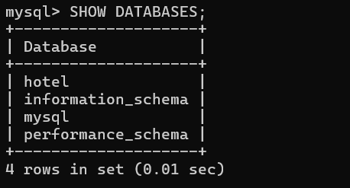
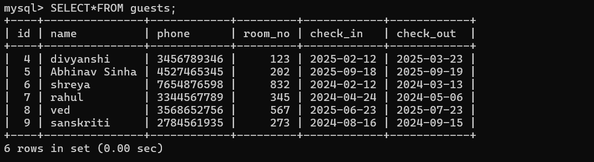
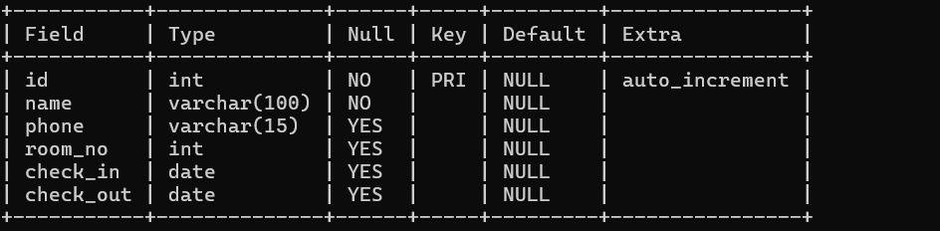

REFERENCES:

1. CLASS 11th& 12th Computer Science Book (SUMITA ARORA)

2. PYTHON

https://www.python.org/

3. MySQL

https://www.mysql.com/

4. KV Coders

https://kvcoders.in

79874: 5. IRCTC:

https://www.irctc.co.in/nget/

train-search

Output

